
Child Protection Working Group
Contact List – Guidance Note

All CPWG generic tools are developed based on best practices from the field. If you decide to use these tools in your context, make sure they are contextualized before use for quality results.
What is a contact list for?
A contact list helps:
- Keeping attendance from meetings
- Contacting Field Based Coordination Group’s members and sharing information with them
- Having an overview of who are the members (by organisation, type of organisation, etc.)
Who can update the contact list?
The Field Based Coordinator or the Information Management Officer (IMO). Note that using and updating the contact list only requires basic Excel skills.
Who is the audience?
Field Based Coordination Group’s members are the main audience. Sometimes, journalists can ask for contacts in CPiE and you can provide them with some key contacts from the contacts list (after receiving their consent). UNOCHA can also use the contact list to develop the country humanitarian contact list.
Format
The template has been designed on MS Excel. The sheet contains the following columns: Organisation, Type of Organization, Acronym, Name, Function, Phone Number (1 & 2), Email and Signature. The columns can be changed and adjusted to the needs.
How to create and update a contact list?
- The sheet is protected by default. This means columns cannot be added or deleted; filtering from A to Z cannot be used, etc. The sheet is protected to avoid errors on formulas. However, if the template needs to be modified, the sheet can be unprotected by selecting the ‘Review’ tab from the MS Excel ribbon (top of the page), then selecting ‘Unprotect sheet.’ When the changes are made, it is recommended that the sheet be protected again.

Modify the banner:
- On the sheet named ‘CONTACT LIST’, modify the banner: Add the name of the country in place of [Country]. Add the date in place of [DD/MM/YYYY].
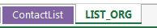
- On the sheet ‘LIST_ORG’, modify, if needed the type of CPWG members.
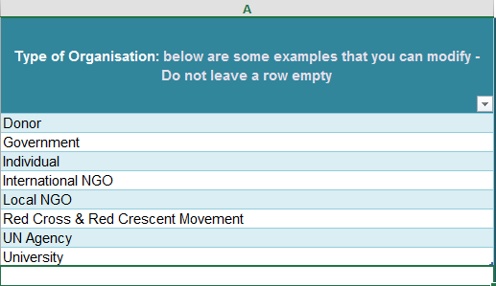

Add the name of new organization(s):
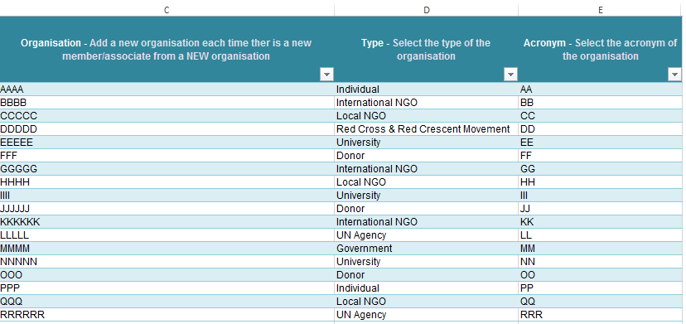
- On the sheet named ‘LIST_ORG’, add the name of the organization in the first column, then select the type of the organization from the drop-down menu and add its acronym. You do not have to do this anymore for this organization. Repeat it for each new organization you are adding.

Updating the contact list:
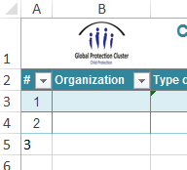
- On the sheet named ‘CONTACT LIST, Add a record number in column A (this is mandatory in order to make the functions appear)

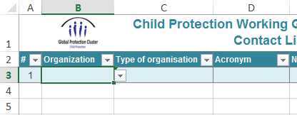
- Select the name of the organization to which the partner belongs in the second column (B) by clicking on the arrow. The type of organization as well as the acronym will appear automatically (do not modify the content of type of organization and Acronym cells).

- In column E, add the Name of the new person.
- In column F add the function/position.
- In column G, add the primary phone number. If needed add another phone number in column H.
- In column I, add the email.
To do before a meeting:
- On the sheet named ‘CONTACT LIST’, select column A to I and the row where there are names. Select few mores lines (5 to 10) should new members come to your meeting. Click on page layout and print area. Then print the contact list. Ask participants in your meeting to modify their information if needed and to sign the contact list.
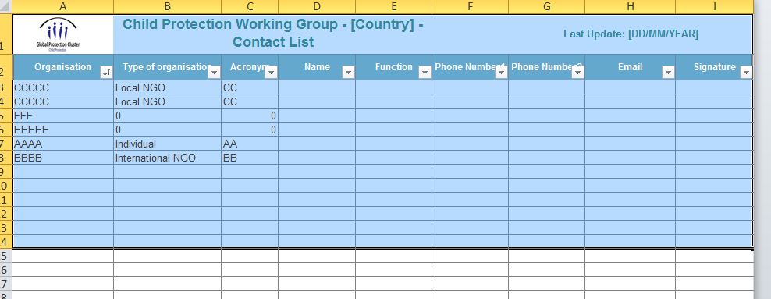
Modify the structure of your contact list (optional)
- Although this structure is considered as a best practice, it can be modified.
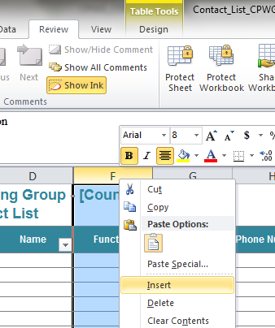
- A new column can now be inserted (select a column, then right click, then select Insert):

- As an example, column E has been hidden. In this column, ‘Yes’ can be inserted if the person is an associate and not members of the CPWG. Then, hide/unhide the columns. Although many columns can be added, remember that the contact list have to be printed on a A4 format.
What else can this contact list do:
- Import contacts on Outlook or Gmail: Simply copy/paste the email cells from the Excel file to the Gmail or Outlook contacts field.
- Using Mailchimp: Mailchimp (http://mailchimp.com/?utm_expid=73579475-27) helps create signup forms, and send yourCPWG members updates, event invitations, announcements, or editorial content. MailChimp is free for lists of up to 2,000 subscribers.

Tips to update a contact list:
- Print the contact list before each meeting: This avoid participants to write their information at each meeting. They now only have to sign the contact list.

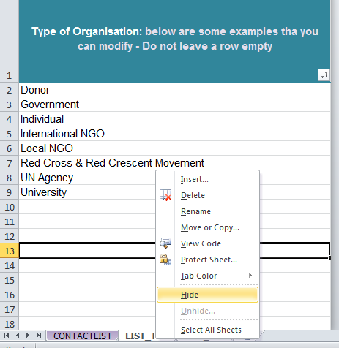
- Update the contact list systematically: After each CPWG meeting or after each new person you meet. The contact list can be shared through emails or through your website if members consider this is not confidential information. Before sending the contact list in Excel format, make sure the tab LIST_ORG is hidden by right clicking on the tab and select Hide.

- Call persons for whom emails bounce back to improve accuracy of contact details.
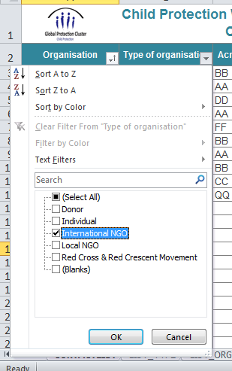
- Make full use of the filter: If only international NGOs should receive an email. The column ‘Type of organisation’ can be filtered and select ‘International NGOs’ can be selected. Filter can also work on each column. Another option is to use the ‘Sort A to Z’ filter, for example on the ‘Name’ column to retrieve a name. To print the contact list it is suggested to sort from A to Z the Organisation column.

- Add more columns: It can help you to provide you with information such as where is this person based (location), if they have participated to meetings, who are the focal points for reporting on your W matrix, etc,

